DRILLING

MUDS ON THE BASIS OF ORGANIC MINERAL RAW MATERIALS

Relevance of the use of drilling muds on the basis of organic mineral raw materials (OMRM)

* 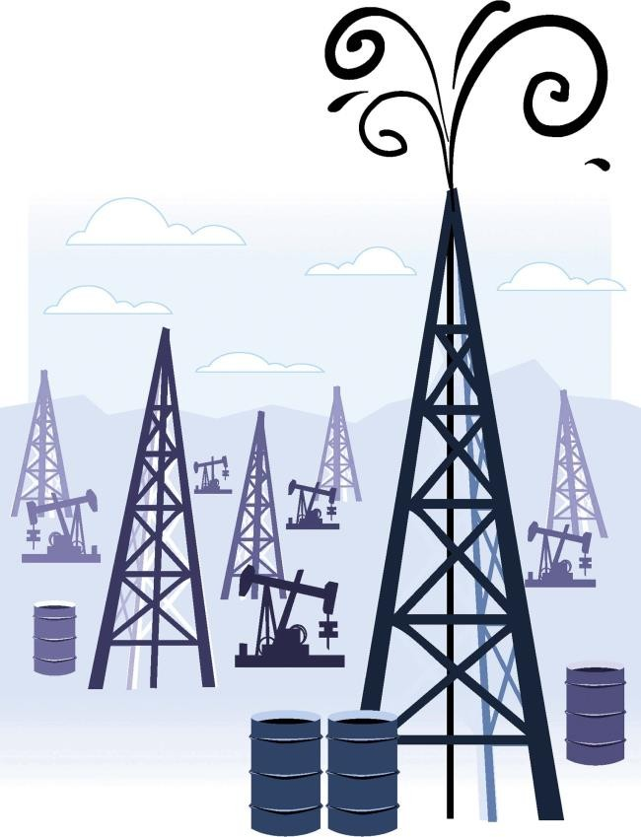DRILLING PROCESS PROVISION

*drilling must carry out a number of that are the more diverse the more complicated the drilling process is: the deeper well, more unstable its walls, the higher gas/oil pressure in horizons being drilled*

* PROVISION OF QUALITATIVE DRILLING OF THE PRODUCTIVE SHAFT

*the mud must minimally pollute the productive formation, preserving*

*potential productivity of the shaft*

* ECONOMIC ADVISABILITY

*the solution must ensure maximum technical and economic boring*

*indicators at optimum cost for preparation of boring solutions and*

*maintenance their parameters*

Requirements

for drilling mud

Drilling mud must

E N S U R E :

* + cleaning of the shaft in the wellbore area and removal of rock particles to the surface;
  + maintaining the stability of the walls of the well;
  + control of the formation pressure at the surface;
  + lubrication and cooling of the bit;
  + stability of the shaft;
  + evaluation of the formation and obtaining undistorted geological information;
  + minimum contamination of the productive formation and maximum improvement in the quality of the opening of the productive formations;
  + reducing the costs of combating complications;
  + the fullest use of technical capabilities of the bits and downhole motors;
  + increase of drilling speeds;
  + increase of the service life of the equipment;

P O S S E S S:

* simplicity in preparation and operation;
* stability in the conditions of the aggressions of various nature (temperature, pressure, contamination by sludge, cement, salts, formation fluids)
  + protection of the environment.

At minimum cost!

Established practice

Alternative

Types of water-based



* service water;
* solutions of salts and hydrogels;
* polymer solutions:
  + *incl. biopolymer and*

*biopolymer with reduced density;*

* clay solutions:
  + *bentonite, palygorskite, etc.;*
  + *with various density;*
  + *with various mineralization (from fresh to highly mineralized)*

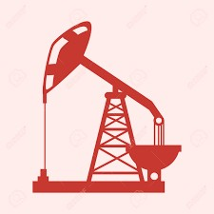

* OMRM-BASED MUD
* including:
  + with various density;
  + with various mineralization (from fresh to highly mineralized).

drilling mud

Comparison of the parameters

of the main used types of muds

with OMRM-based mud

|  |  |  |  |  |  |
| --- | --- | --- | --- | --- | --- |
| Nos. | Technological parameters | UM | Solution | | |
| clayey  bentonite | biopolymer | OMRM-based |
| 1. | Density | kg/m3 | 1060-1100 | 1050-1100 | 1030-1100 |
| 2. | Conditional viscosity | s | 25-40 | 35-60 | 25-60 |
| 4. | Plastic viscosity | dPa**.**s | 8-30 | 30-60 | 20-40 |
| 5. | Dynamic shear stress | dPa | 30-100 | 60-130 | 35-100 |
| 6. | Static shear stress | dPa | 5/20 | 10/30 | 10/30 |
| 7. | Filtration (Р=0,1 MPa) | cm3/30 min | >15 | 4-10 | 3-10 |
| 8. | Hydrogen index | pH | 7.5-8 | 9.5-11 | 8.0-10 |
| 9. | Thickness of crust | mm | 0.5 | 0.2 | 0.2 |
| 10. | Content of sand (not more than) | % | 1 | 0.5 | 1 |

Comparative characteristics **rheological** and **inhibitory** properties of the main types of muds for opening productive horizons

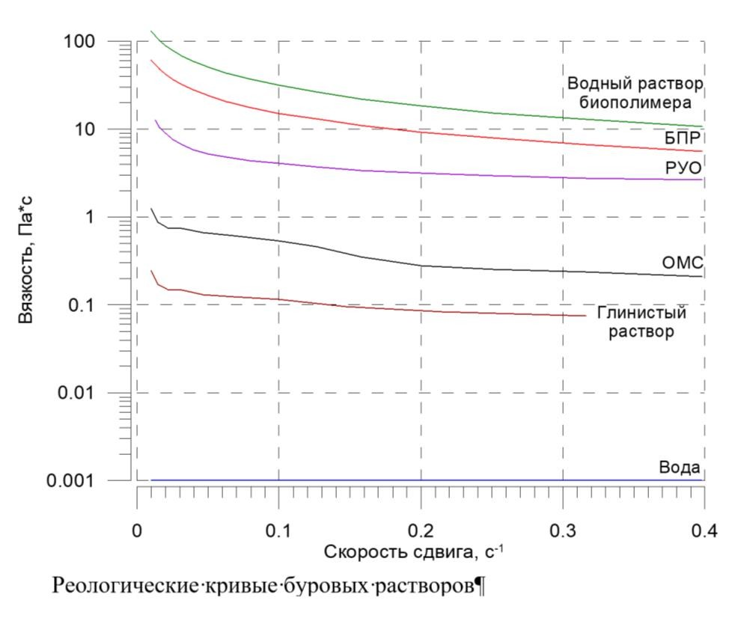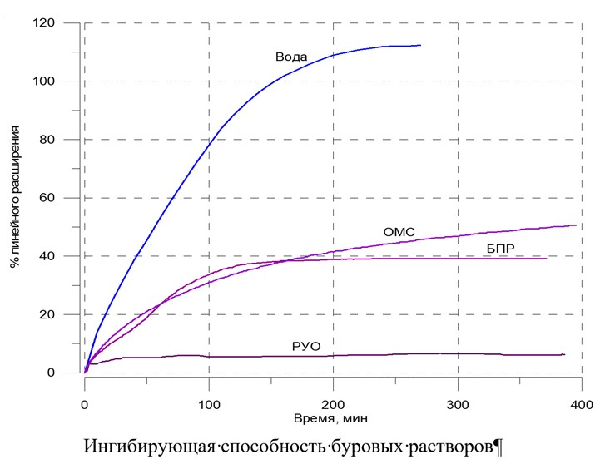

Biopolymer solution

Viscosity, Pa·s % linear expansion

Aqueous polymer solution Water

Biopolymer solution OMRM

Hydrocarbon-based solution Biopolymer solution

OMRM Hydrocarbon-based solution

Clayey solution Time, min

Water

Shear rate, s·1

Rheological curves of drilling muds

Comparison of the effectiveness of use of drilling muds of various types for opening productive horizons

|  |  |  |  |  |
| --- | --- | --- | --- | --- |
| Nos. | Permeability of the disk, μm2 | Drilling mud | Quantity of solution passed through the disk before the formation of the screen, cm3 | Permeability recovery factor of the disk % |
| 1 | 100 | Hydrocarbon-based solution | 255 | 75 |
| 2 | OMRM-based mud  with acid-soluble fillers | 5.4 | 74.4 |
| 3 | Biopolymer mud  with acid-soluble fillers | 20 | 100 |
| 4 | 0,75 | Hydrocarbon-based mud | 50 | 20.6 |
| 5 | OMRM-based mud  without fillers | 0 | 78.4 |
| 6 | OMRM-based mud  with acid-soluble fillers | 0 | 100 |
| 7 | Biopolymer mud | 0 | 52 |
| 8 | Biopolymer mud  with acid-soluble fillers | 0 | 79 |
| 9 | Biopolymer mud  with acid-soluble fillers | 0 | 92 |
| 10 | Service water containing solid phase  0,01 weight.% | 1600 | 46.4 |

OMRM-based solution

with acid-soluble fillers

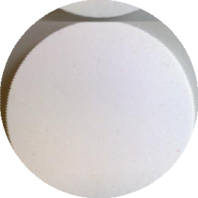

Clean disk 0.75 μm2

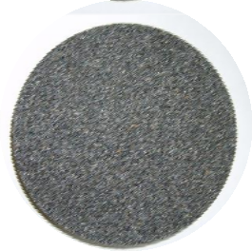

Clean disk 100 μm2

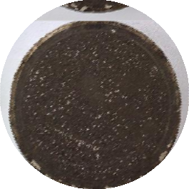

Blocking screen on the disk 0.75 μm2

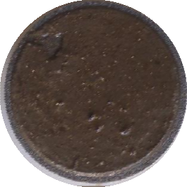

Blocking screen on the disk 100 μm2

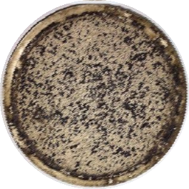

Disk 0.75 μm2 after the destruction of the blocking screen by water backwashing, Prr=100%

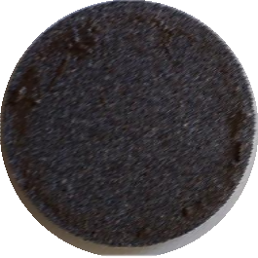

Disk 100 μm2 after the destruction of the blocking screen by water backwashing, Prr=74,4%

Reagents for adjusting parameters

of drilling muds of various types

|  |  |  |  |  |
| --- | --- | --- | --- | --- |
| **Nos.** | **Parameter** | **Mud** | | |
| clayey bentonite | biopolymer | OMRM |
| **1.** | Rheology | 1. dеcrease:    * service water    * reagent diluent    * inhibitors 2. increase:    * cross-linking reagents | 1. decrease:    * service water    * reagent diluent 2. increase:    * cross-linking reagents    * polysaccharides | 1. decrease:    * service water (without critical deterioration of filtration characteristics)    * OMRM mud (minimum concentration) 2. increase:    * OMRM-based paste |
| **2.** | Filtration | resins  starches and derivatives of starches  carboxyl methylcellulose;  acrylates, etc. | starches and derivatives of starches  carboxyl methylcellulose; | OMRM-based paste |

OMRM-BASED MUD IS SELF-SUFFICIENT.

Advantages of OMRM-based mud

5.

Environmental safety

natural origin;

1.

Simplicity in preparation

приготовления

Minimum of componentsнентов

2.

Simplicity in operation of the mud

high resistance to various kinds of aggressions;

stability of parameters (reducing the number of treatments);

compatibility with various types of muds (including cement ones);

compatibility with the majority of reagents for adjusting parameters;

3.

Wide range of parameters

the mud is suitable for drilling various horizons (from the conductor to the production string);

if necessary, it is easily converted in a mineralized system;

4.

Economic efficiency

low cost of the reagent

реагента;

low cost of operation of the mud

reusability;

Fields of application of organic mineral raw materials (OMRM)

|  |  |  |
| --- | --- | --- |
| **Drilling** | | |
| **Conductor** |  | 1. Fresh OMRM-based drilling mud |
| **Protective string** |  | 1. Fresh OMRM-based drilling mud    1. inhibitory    2. polymer treated 2. Salt-saturated OMRM-based drilling mud    1. starch treated    2. weighted |
| **Production string** |  | 1. Fresh OMRM-based drilling mud 2. Fresh OMRM-based drilling mud with acid-soluble   fillers   1. OMRM-based emulsion of the 1st kind with reduced density |
|  |  |  |
| **Other downhole operations** | | |
| **Strengthening of wells** |  | 1. Buffer fluids |
| **Liquidation of absorptions** |  | 1. Colmatant carrying fluid 2. Colmatant (in dry form) |
| **Overhaul of wells** |  | 1. Kill fluid |

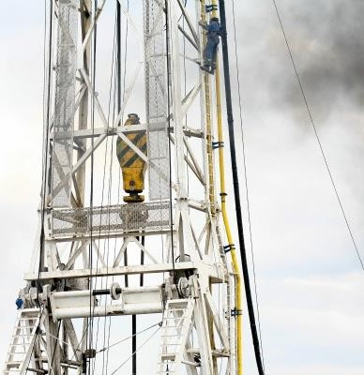

Thanks for your attention!